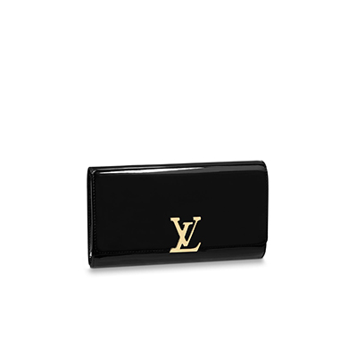

Louise Clutch Leather Evening Bag

PRODUCT DETAILS

**25 x 14.5 x 4 cm**

**- 9.8 x 6 x 1.5 inches**

**- Smooth calfskin exterior**

**- Microfiber lining**

**- Gold colored metallic pieces**

**- LV magnetic lock**

**- 2 flat inside pockets**

**- Inside zipped pocket**

**- Tone -on- tone edge dyeing**